- KPIs: Create KPI cards displaying the following metrics: Total Revenue, Total Quantity Sold, Total Orders, Average Order Value and Average Pizza per Order (0.5 pts).
- Total Revenue: $817.86K
- Total Quantity Sold: 50K pizzas
- Total Orders: 21K orders
- Average Order Value (AOV): $38.31
- Average Pizzas per Order: 2.32
Customers typically purchase more than one pizza per order, indicating strong combo-buying behaviour and opportunities for upselling.
- Sales Trends and Anomalies
- Analyse and present daily, weekly, and monthly sales trends across 2015 (0.25 pts).
- Lowest sales weeks: Week 1, Week 39, Week 52 (~$9.8K)
- Highest sales week: Week 48 (~$19.7K)
- Typical weekly range: $13K – $17K
- Lowest months:
  - October (~$64K, worst)
- February, September, December also underperform
- Best month:
  - July (~$72.5K)
- Other strong months:
  - March, May, November (above $70K)
Sales fluctuate seasonally, with clear dips toward year-end and early-year periods.
- Identify peak sales periods, patterns, and any seasonal trends (0.25 pts).
- Mid-year (especially July) is the strongest period:
  - 04/07/2015: $3.89K
  - 17/03/2015: $2.97K
  - 15/05/2015: $3.39K
- Significant drop at:
  - Start of the year (post-holiday slowdown)
    - 22/02/2015: $1.58K
  - Late Q3 (September–October):
    - 06/09/2015: $1.5K
    - 28/10/2015: $1.64K
  - End of year (December):
    - 30/12/2015: $1.34K
- Possible reasons:
  - Post-holiday reduced spending
  - Seasonal demand changes
  - Weather or holiday travel patterns
- Investigate sales performance by day of the week and time of day (0.25 pts).
From the heatmap:
- Peak hours:
  - 12 PM – 1 PM (highest revenue across all days)
- Strong periods:
  - Lunch (12–2 PM)
  - Early evening (5–7 PM)
- Best performing days:
  - Thursday, Friday and Saturday
- Weak periods:
  - Late night (after 9 PM)
  - Early morning (Before 11AM)
Insight:
- Business is highly driven by lunch and dinner demand, with weekends performing strongest.
- Sunday and Monday has the lower sales, showing weak demand at the end and the beginning of the week
- Examine and identify the potential causes behind significant sales spikes or drops on specific dates throughout the year (0.25 pts).
- Spikes may be driven by:
  - Weekends and social dining behaviour
  - Seasonal peaks (mid-year demand)
- Drops may be caused by:
  - Post-holiday spending cuts
  - Seasonal low-demand months (Feb, Sep, Oct)
  - Reduced activity during holiday travel periods
- Product Performance Analysis
- Rank pizza categories by total quantity sold and revenue generated (0.25 pts).
Category | Quantity Sold | Revenue
Classic | 14,888 | $220K
Supreme | 11,987 | $208K
Chicken | 11,050 | $195K
Veggie | 11,649 | $193K

- Classic leads in both quantity and revenue
- Supreme generates high revenue despite lower volume, which means it has higher pricing compared to other categories
- Categories are relatively balanced overall
- Identify the top 5 and bottom 5 pizzas by both quantity and revenue (0.25 pts).
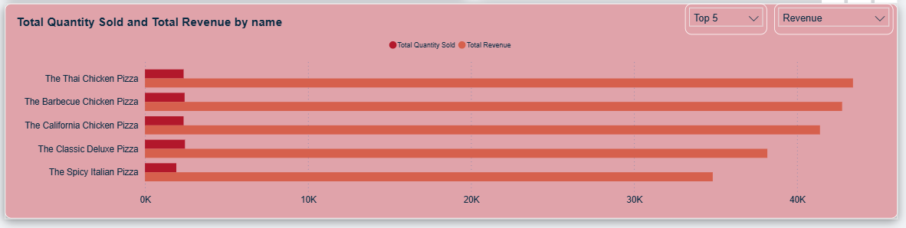
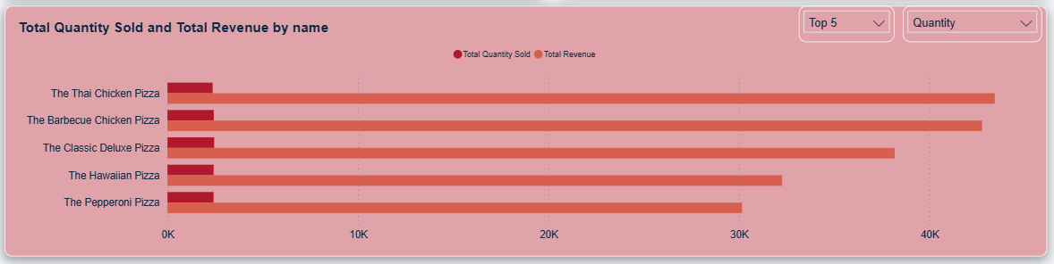
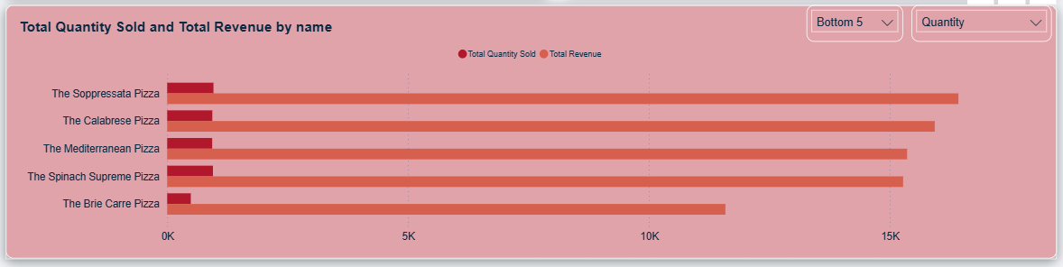
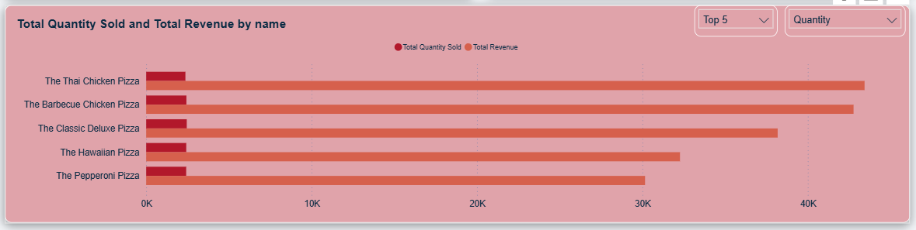
A few underperforming pizzas significantly lag behind in quantity term, but the revenue generated will also be considered alongside quantity sold to assess whether menu optimization or product removal is justified.
- Size and Ingredient Analysis
- Analyze the relationship between pizza size and sales volume within each category (0.25 pts).
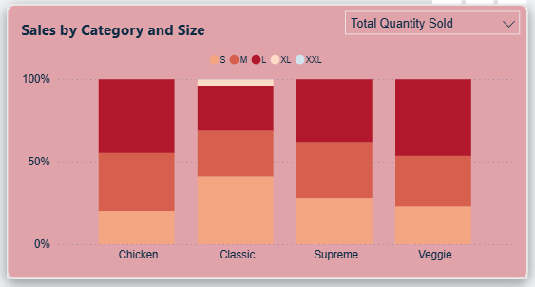
- Large (L) dominates in most categories
- Large (L), Medium (M) and Small (s) are popular sizes.
- XL and XXL contribute very little to the sales
- Classic category:
  - Small (S) performs best
  - XL and XXL contribute minimally:
    - XL: ~4%
    - XXL: <1%
Customers prefer standard sizes (S, M, L). Larger sizes are niche and not impactful
- Identify the most and least popular ingredients for each pizza category based on quantity sold (0.5 pts).
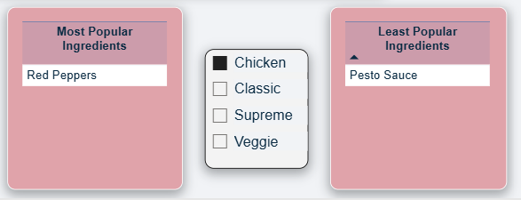
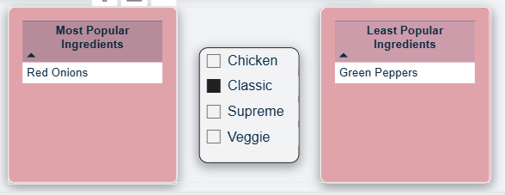
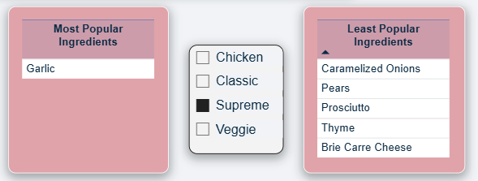
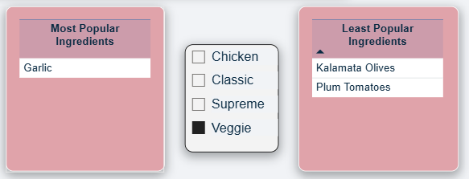
Garlic is a strong cross-category favourite
- Order and Ingredient Correlations
- Investigate the correlation between total revenue contributed to and total quantity sold by specific ingredients. Use two average reference lines to segment the ingredients into four distinct groups for comparison (0.25 pts).

The correlation coefficient (r = 1) indicates a perfect positive relationship between quantity sold and revenue. However, this is expected because revenue is directly calculated from quantity (Revenue = Price × Quantity). Therefore, the strong correlation reflects a mathematical dependency rather than an independent relationship.

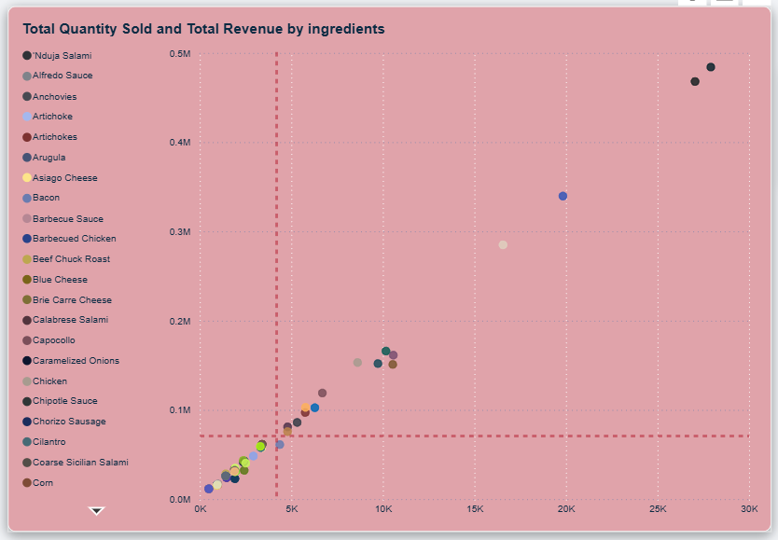

- Top-right (High Quantity, High Revenue)
Key-performing ingredients that drive both volume and revenue. These are the most valuable and should be maintained or promoted, such as garlic, tomatoes, red peppers, red onions.
- Top-left (Low Quantity, High Revenue)
High-revenue but lower-volume ingredients, possibly premium items. These may offer strong margins but limited demand. However, there is no ingredient falls in this quadrant.
- Bottom-right (High Quantity, Low Revenue)
High-volume but lower-revenue ingredients, likely lower-priced. These contribute to sales volume but less to profitability (e.g. bacon)
- Bottom-left (Low Quantity, Low Revenue)
Underperforming ingredients with minimal contribution. These may be considered for removal or repositioning. Bottom 1 includes: Thyme, Prosciutto, Pears, Caramelized Onions, Brie Carre Cheese
- Explore the correlation between average pizza prices and total sales volume across categories and include a trend line. (0.25 pts).
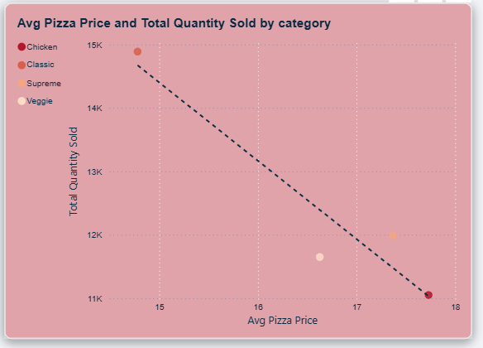

The calculated correlation coefficient is r = -0.95
This indicates a strong negative correlation between average pizza price and total sales volume:
- As the average price of pizzas increases, the total quantity sold decreases significantly
- Lower-priced categories, such as Classic, achieve higher sales volumes
- Higher-priced categories, such as Chicken and Supreme, tend to have lower demand
The downward-sloping trend line in the chart further supports this inverse relationship.
Insight:
- Price is a key factor influencing demand, with customers showing clear sensitivity to higher prices.
- Order Frequency and Timing
- Analyze the frequency of single-item vs. multi-item orders (0.5 pts).
- Single-item orders:
  - 38.41% of quantity
  - Total orders: 8201
- Multi-item orders:
  - 61.59% of quantity
  - Total orders: 13149
- Insight:
Multi-item orders dominate, resulting in strong opportunity for:
  - Combo deals
  - Upselling strategies
- Examine the average time interval in minutes between orders (0.25 pts).
Average time between orders: 11.01 minutes
Therefore, demand is consistent throughout the day, especially during peak hours.
- Business Recommendations
- Optimize Pricing Strategy
  - Introduce mid-range pricing tiers
  - Offer discount bundles to increase volume without lowering margins
- Focus on High-Performing Products
  - Promote top sellers (e.g., Classic Deluxe, BBQ Chicken)
  - Bundle popular pizzas with drinks/sides
- Improve Low-Performing Items
  - Remove or redesign bottom performers (e.g., Brie Carre)
  - Replace unpopular ingredients
- Leverage Peak Hours
  - Increase staffing during:
    - Lunch (12–2 PM)
    - Dinner (5–7 PM)
  - Run time-based promotions during slow hours
- Boost Seasonal Sales
  - Target low months (Oct, Feb, Dec) with:
    - Discounts
    - Marketing campaigns
    - Limited-time offers
- Encourage Multi-Item Orders
  - Create:
    - Combo deals (e.g., “Buy 2 Get 1”)
    - Family bundles
  - Offer incentives for larger orders
- Menu Engineering
  - Focus on high-demand ingredients (garlic, red onions)
  - Reduce use of low-performing ingredients

